Unit 3 SQL Aggregates and Groupings

Corey Crooks
Purdue University Global
IT350 – Advanced Database Concepts
Jason Johnson
February 22nd, 2023

Problem 1: Establish a database view called TotalBikesSoldView that lists each bike name and associated total quantity sold. Then query the view to show the top ten bikes sold. Present the output in descending order based on total bikes sold.
USE BikeStores

CREATE VIEW TotalBikesSoldView AS
SELECT product_name, SUM(quantity) AS "Total Sold"
FROM Production.Products PR
INNER JOIN Sales.Order_Items OI
ON PR.product_id = OI.product_id
GROUP BY product_name;

SELECT TOP 10 * FROM TotalBikesSoldView
ORDER BY "Total Sold" DESC;
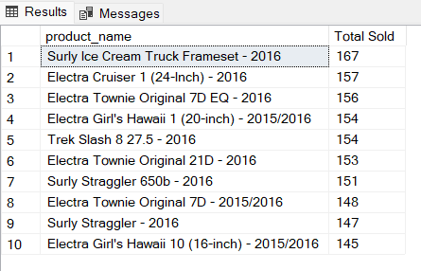

Problem 2: Establish a database view called MaximumBrandBikePriceView that lists each bike brand and associated maximum bike price. Then query the view and present the output in ascending order based on the bike brand name.
USE BikeStores

CREATE VIEW MaximumBrandBikePriceView AS
SELECT brand_name, MAX(list_price) AS MaxPrice
FROM Production.Products PR INNER JOIN Production.Brands BR
ON PR.brand_id = BR.brand_id
GROUP BY brand_name;

SELECT * FROM MaximumBrandBikePriceView
ORDER BY brand_name;
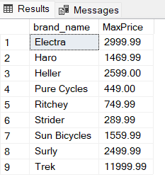

Problem 3: Establish a database view called AverageBrandBikePriceView that lists each bike brand name and associated average bike list price and list price standard deviation. Then query the view and present the output in ascending order based on the bike brand name.
USE BikeStores

CREATE VIEW AverageBrandBikePriceView AS
SELECT brand_name, AVG(list_price) AS AvgPrice,
STDEV(list_price) AS StdDevPrice
FROM Production.Products PR INNER JOIN Production.Brands BR
ON PR.brand_id = BR.brand_id
GROUP BY brand_name;

SELECT * FROM AverageBrandBikePriceView
ORDER BY brand_name;
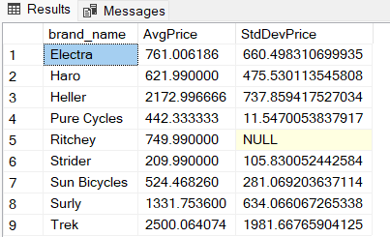

Problem 4: Establish a database view called NumberOfCustomersPerStateView that lists the number of customers in each state. The view needs to show the state name along with the customer amount. Then query the view and present the output in ascending order based on state.
USE BikeStores

CREATE VIEW NumberOfCustomersPerStateView AS
SELECT state, COUNT(*) NumCustomers
FROM Sales.customers
GROUP BY state;

SELECT * FROM NumberOfCustomersPerStateView
ORDER BY state;
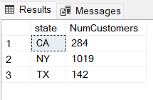

Problem 5: Establish a database view called TotalBikesSoldPerStateView that shows the cumulative bike sales per state. The view needs to show the state name along with the bike sales quantity. Then query the view and present the output in ascending order based on state.
USE BikeStores

CREATE VIEW TotalBikesSoldPerStateView AS
SELECT state, SUM(quantity) AS NumBikesSold
FROM Sales.customers C INNER JOIN Sales.orders O
ON C.customer_id = O.order_id
INNER JOIN Sales.order_items OI
ON O.order_id = OI.order_id
GROUP BY state;

SELECT * FROM TotalBikesSoldPerStateView
ORDER BY state;
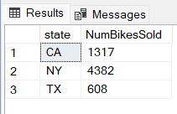

Problem 6: Create a stored procedure that lists the stock quantity at each store for a specified bike brand. The output must show the store name and stock quantity value. The results need to be presented in ascending order based on the store name. The skeleton of the stored procedure is provided below.
USE BikeStores

CREATE PROCEDURE GetStoreBrandStockQuantity
@BrandName VARCHAR(255)
AS
SELECT store_name, SUM(quantity) AS StockAmt
FROM Sales.stores ST INNER JOIN Production.stocks SK
ON ST.store_id = SK.store_id
INNER JOIN Production.products PR
ON SK.product_id = PR.product_id
INNER JOIN Production.Brands BR
ON PR.brand_id = BR.brand_id
WHERE brand_name = @BrandName
GROUP BY store_name
ORDER BY store_name;

EXEC GetStoreBrandStockQuantity @BrandName='Trek';
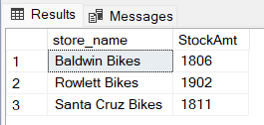

Problem 7: Create a stored procedure that lists the average, standard deviation, maximum, and minimum list prices for a specified bike brand. The output must show the brand name along with the aggregated results. The results need to be presented in ascending order based on the store name. The skeleton of the stored procedure is provided below.
USE BikeStores

CREATE PROCEDURE GetBrandListPriceStatistics
@BrandName VARCHAR(255)
AS
SELECT brand_name,
AVG (list_price) AS PriceAvg,
STDEV(list_price) AS PriceStdDev,
MAX (list_price) AS PriceMax,
MIN(list_price) AS PriceMin
FROM Production.products PR
INNER JOIN Production.brands BR
ON PR.brand_id = BR.brand_id
WHERE brand_name = @BrandName
GROUP BY brand_name;

EXEC GetBrandListPriceStatistics @BrandName='Trek';
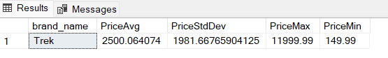

Problem 8: Create a stored procedure that lists the bike categories with minimum list prices below a specified value. The output must show the bike category and associated minimum list price. The results need to be presented in ascending order based on the bike category. The skeleton of the stored procedure is provided below. (Hint: The HAVING clause needs to be used.)

USE BikeStores

CREATE PROCEDURE GetBikeCategoriesWithMinPriceBelowValue
@Price DECIMAL(10,2)
AS
SELECT category_name, MIN(list_price) AS MinListPrice
FROM Production.Products PR INNER JOIN Production.Categories CA
ON PR.category_id = CA.category_id
GROUP BY category_name
HAVING MIN(list_price) <= @Price
ORDER BY category_name;

EXEC GetBikeCategoriesWithMinPriceBelowValue @Price=500;
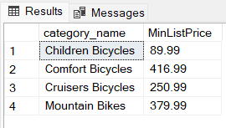

Problem 9: Create a stored procedure that lists the stock quantity for each bike category at a specified store. The output must show the bike category and stock quantity value. The results need to be presented in ascending order based on the bike category. The skeleton of the stored procedure is provided below.
USE BikeStores

CREATE PROCEDURE GetCategoryStockQuantityForStore
@StoreName VARCHAR(255)
AS
SELECT category_name, SUM(quantity) AS NumBikes
FROM Production.categories CT INNER JOIN Production.products PR
ON CT.category_id = PR.category_id
INNER JOIN Production.stocks SK
ON PR.product_id = SK.product_id
INNER JOIN Sales.stores ST
ON SK.store_id = ST.store_id
WHERE ST.store_name = @StoreName
GROUP BY category_name
ORDER BY category_name;

EXEC GetCategoryStockQuantityForStore @StoreName='Santa Cruz Bikes';
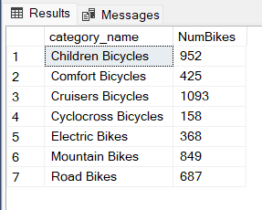

Problem 10: Create a stored procedure that presents the sales discount average and standard deviation for bike brands at or above a specified discount value. The output must show the brand names in alphabetical order along with the associated statistics. The skeleton of the stored procedure is provided below. (Hint: The HAVING clause needs to be used.)
USE BikeStores

CREATE PROCEDURE GetBrandAverageSalesDiscountAboveValue
@Discount DECIMAL(4,2)
AS
SELECT brand_name,
AVG(discount) AS DiscAvg,
STDEV(discount) AS DiscStdDev
FROM production.brands BR INNER JOIN production.products PR
ON BR.brand_id = PR.brand_id
INNER JOIN Sales.order_items OI
ON PR.product_id = OI.product_id
GROUP BY brand_name
HAVING AVG(discount) >= @Discount
ORDER BY brand_name;

EXEC GetBrandAverageSalesDiscountAboveValue @Discount=0.11;
